**CEIS**

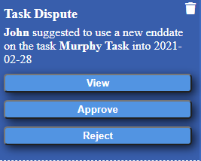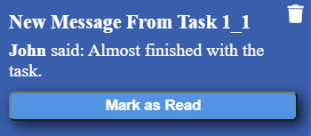******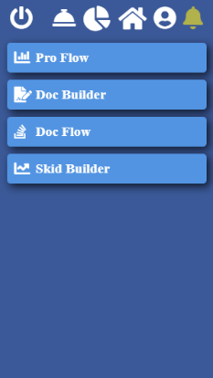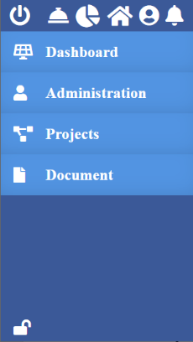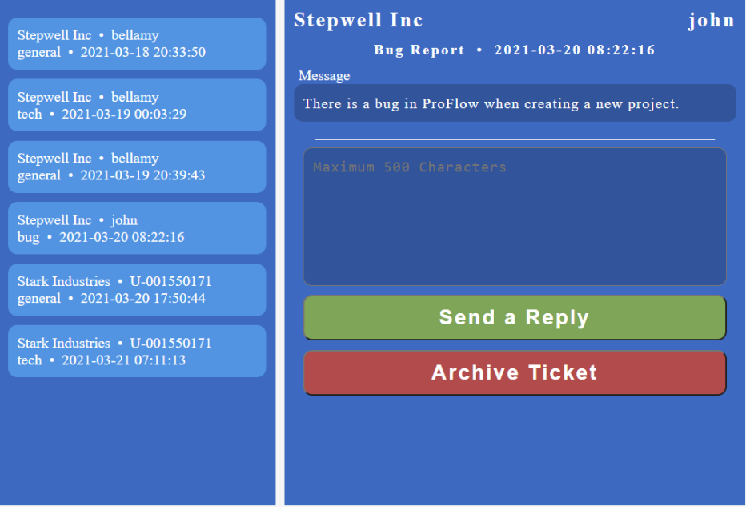

Notification Alerts

* Provides notification alert
* Types of Notification

1. Message
2. Page Redirect Message
3. Single Action Message
4. Multi Action Message

**Software Features** (User Access)

Logout

* Single click logout button Logout from
* Navigation
* Logout from Profile Bar

Quick Access

* Provides a fast and easy way to Modules
* Only Accessible by Admins (user level 1)

Navigation Lock

* Prevents side navigation from expanding

Complains

* Receive complains from users
* Send response to users
* Types of Complains

1. General Inquiry
2. Bug Report
3. Tech Assistance

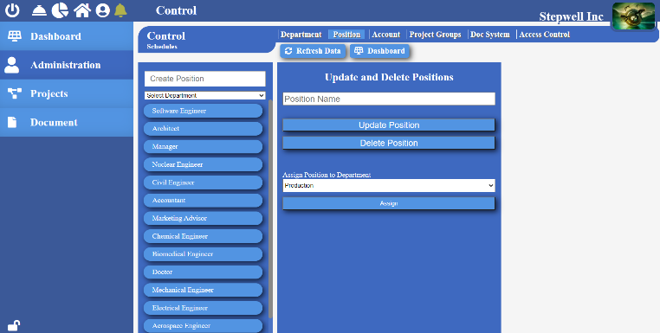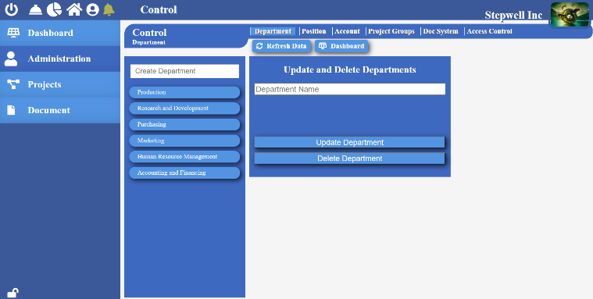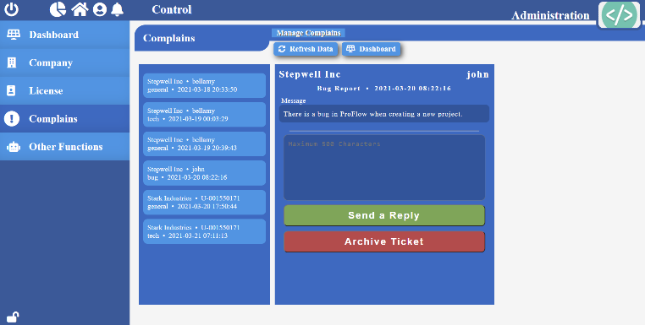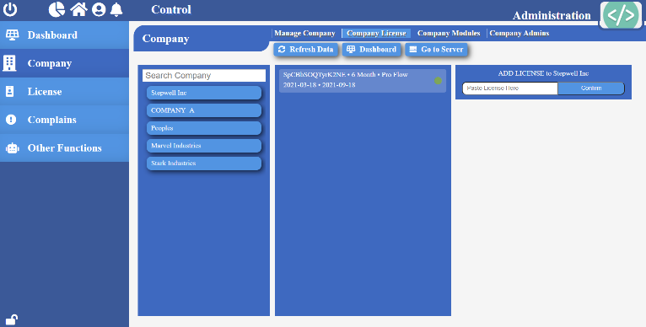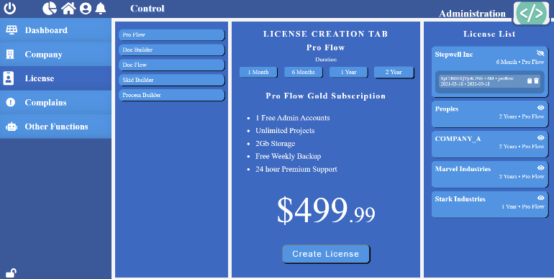

Positions (Company Admin Access)

* View a list of all the work positions available in the company
* Add, update, and remove work position
* Assign positions to departments

**Company – Admin Control**

Department (Company Admin Access)

* View a list of all the departments in the company
* Add, update, and remove company departments

Complains (Software Admin Access)

* View and manage complains received from users
* Send response to complains

Licenses (Software Admin Access)

* Create license keys for various modules
* View a list of assigned licenses for all companies

**Software - Admin Control**

Company (Software Admin Access)

* Create and manage companies
* Assign licenses to companies
* Assign various modules
* Create and manage company admins

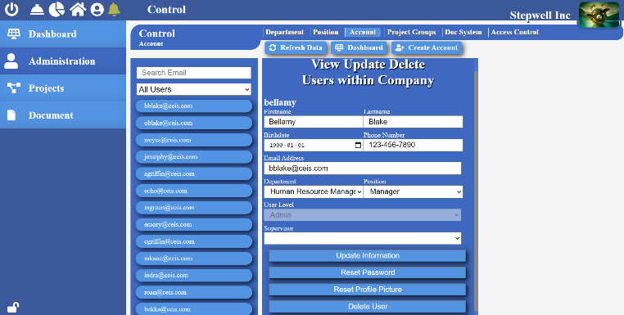

Accounts (Company Admin Access)

* View a list of all users accounts in the company
* Add and update company users accounts
* Assign positions to users
* Assign supervisor

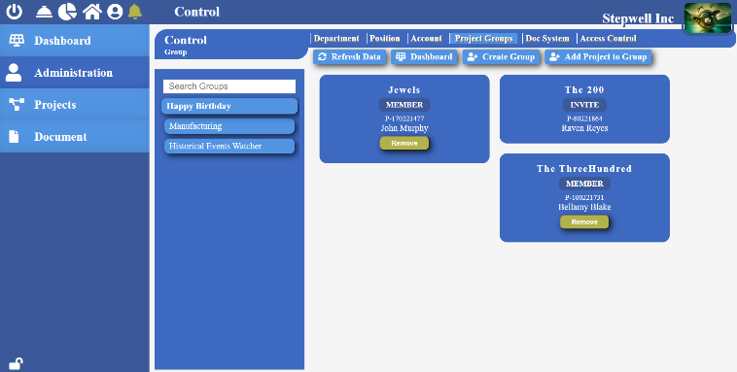

Project Groups (User Access)

* Create and manage group of projects
* View, add, and remove users from project group

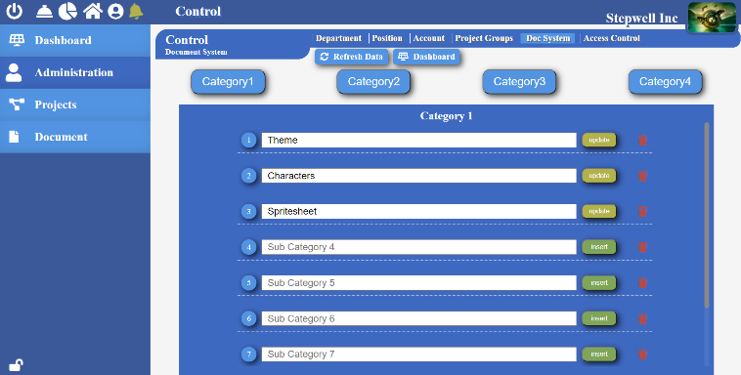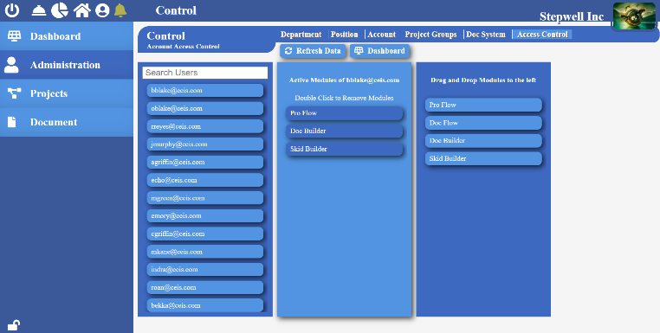

Doc System (Company Admin Access)

* Organize documents by categories
* Create custom document categories and subcategories

Access Control (Company Admin Access)

* Provide access to module to your company users
* Restrict module access to chosen users

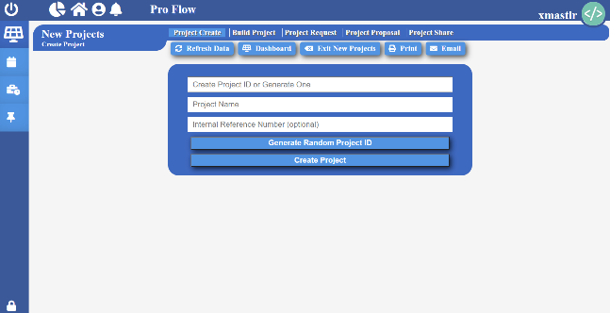

**Company - ProFlow**

New Projects (User Access)

Create Projects

* Create multiple projects
* Connect multiple users to your project

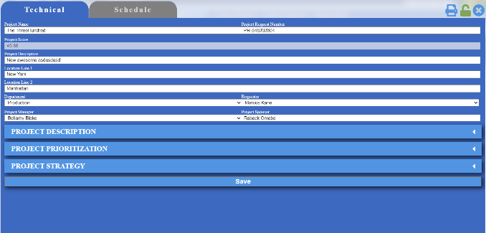

Build Project – Technical

* Provide detailed project description
* List priority of the project in details
* Create detailed project strategies

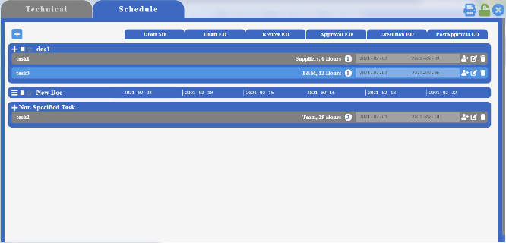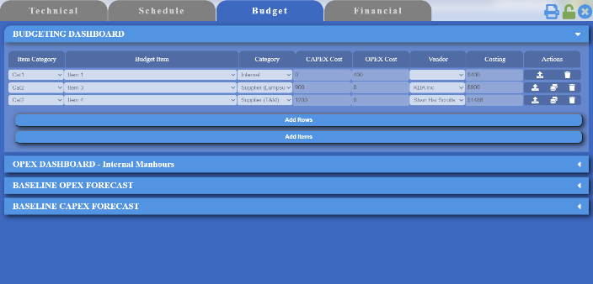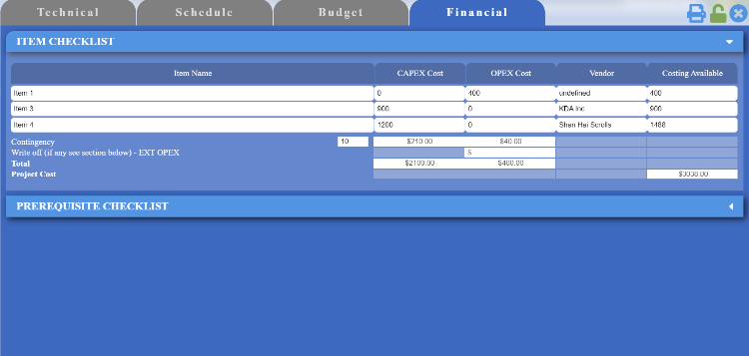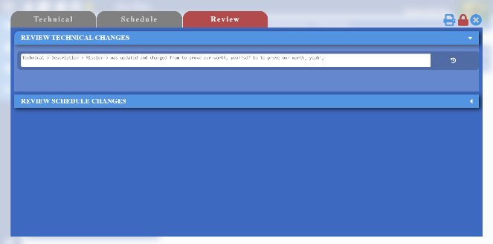

Build Project – Schedule

* Create multiple temporary documents
* Create multiple temporary tasks
* Create and assign multiple temporary resources

Build Project – Budgeting

* Assign hours and rate for all temporarily created resources
* Create a detailed budget schedule for all your resources
* Upload invoices for your suppliers

Build Project – Financial

* View and manage financial aspect of the project

Project Lock

* Record and track any changes made by your colleagues
* View and revert all the recorded changes

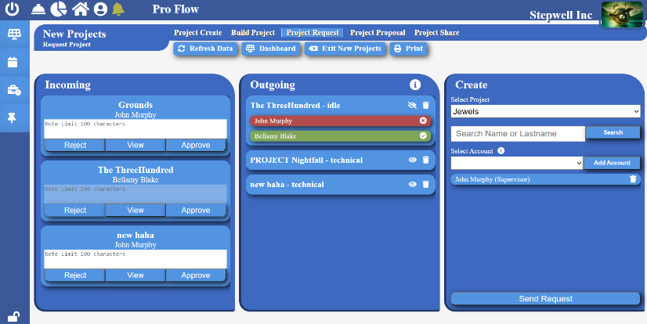

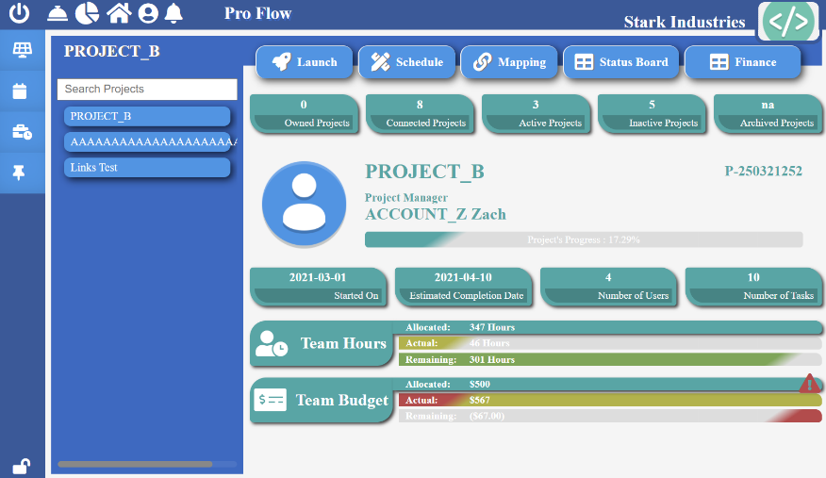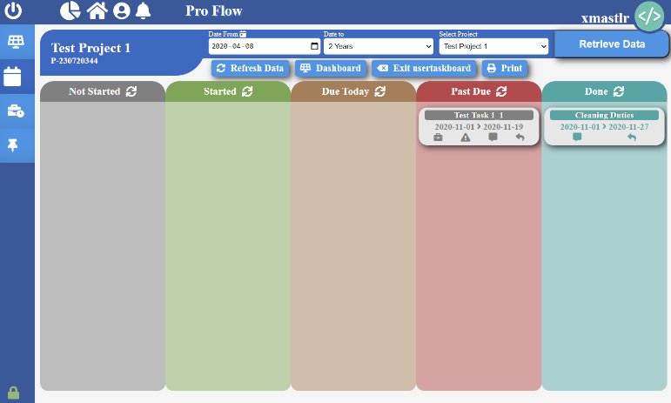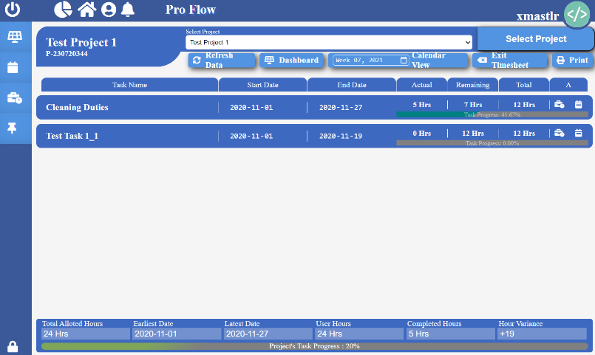

**Company - ProFlow**

Active Projects (PM & Supervisor Access)

Dashboard

* Track overall progress of your project
* Display number of users and tasks connected to the project
* Overview of team hours
* Overview of project budget

**Company - ProFlow**

My Task Board (User Access)

* Detailed view of your tasks and their deadlines
* User’s can indicate task has been started
* Send quick message to project manager regarding a particular task
* View incoming messages from project manager regarding a particular task

**Company - ProFlow**

Project Timesheet (User Access)

* Assign hours to task
* View start and end date of the task
* View precisely when and total hours worked on a task each week
* View tasks progress and remaining hours

Project Request

* Send project for review and approval
* Send project request to multiple users

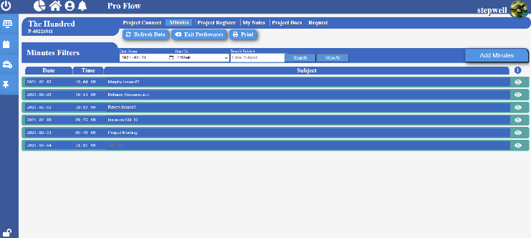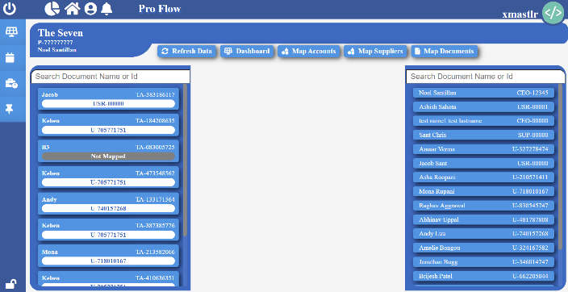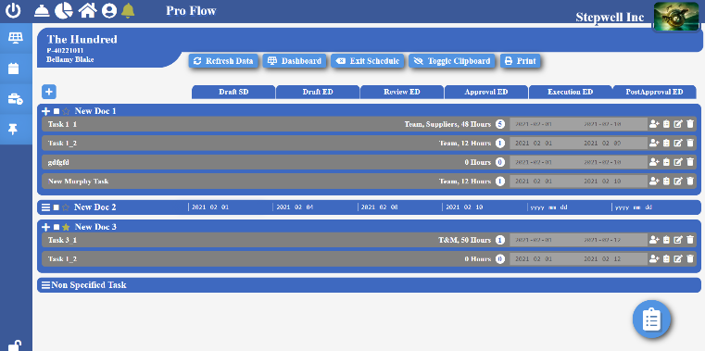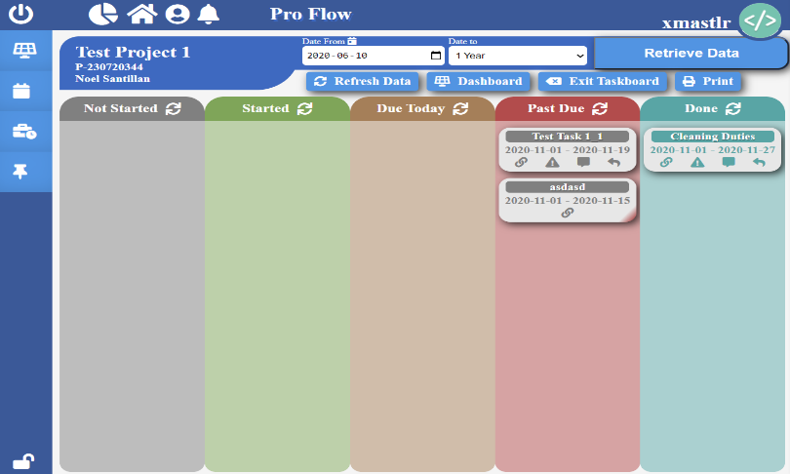

Launch

* Connect more users to the active project
* Create, view, and distribute project minutes
* Create, view, and delete project register
* Create, view, and delete project notes
* View a list of all uploaded documents
* View and modify technical and financial aspects of the active projects

Mapping

* Map documents – Assign temporary documents schedule to actual documents
* Map resources – Assign responsibilities of temporary resource to actual resource

Schedule Board

* + Detailed view of all project documents
  + Add and update documents stages
  + Assign documents as milestone
  + Add, update, and remove tasks of a document
  + Assign users and/or suppliers to tasks
  + Assign hours to resources

Task Board

* Organized view of all tasks in the project
* View progress of all tasks in the project
* Easy communication with the team assigned to the task
* View and resolve any task disputes

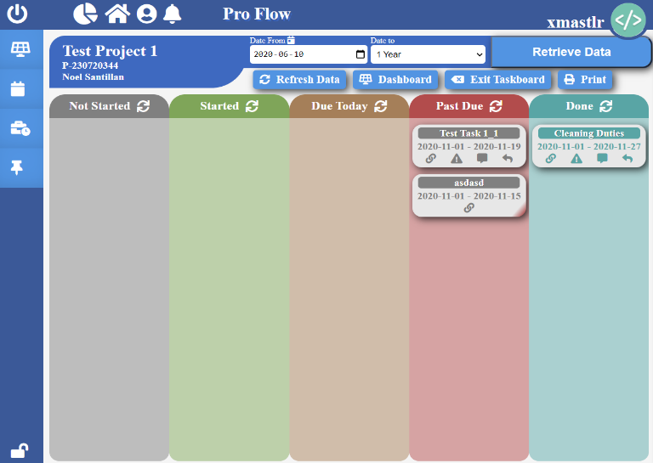

Document Board

* Detailed view of all the documents in the project
* Track progress of all documents (actual and planned)
* View current stage of all project documents
* View start and end date for all stages of all project documents

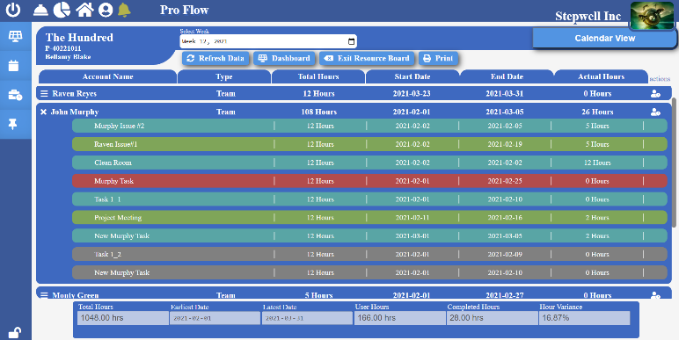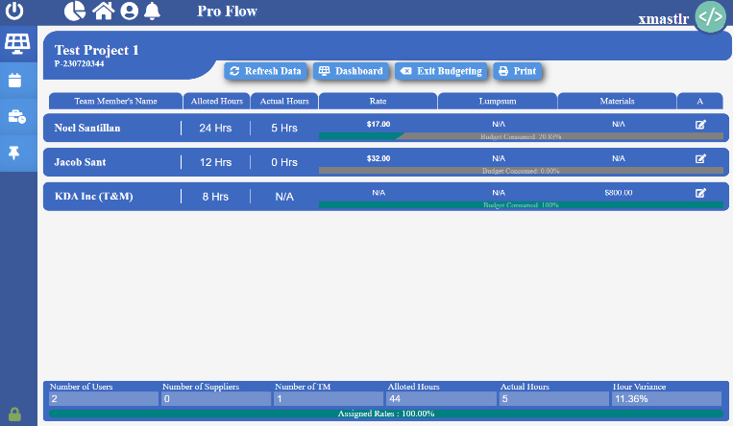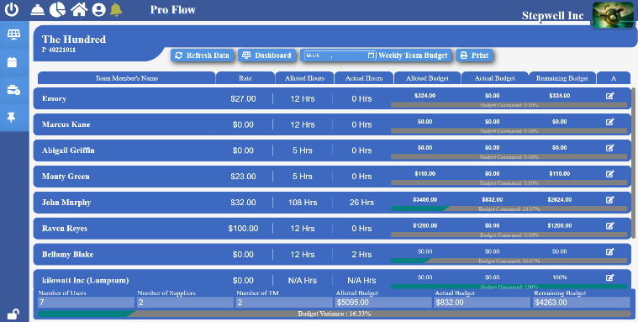

Resource Board

* Track progress of tasks assigned to your inferiors
* View start and end date of the project
* View total allocated project hours, user hours, completed hours, and hour variance
* View total allocated and actual hours of all the users working on the project
* View total allocated and actual hours of all the users’ tasks working on the project

Budgeting Board

* Track progress of resources working on the project
* View allocated hours, actual hours, and hour variance of the project
* View allocated and actual hours of all resources of the project
* View and update rate of all users and suppliers working on the project

Tracking Board

* Track project budget
* View allocated, remaining, and actual budget of the project
* View allocated, remaining, and actual budget of all project resources

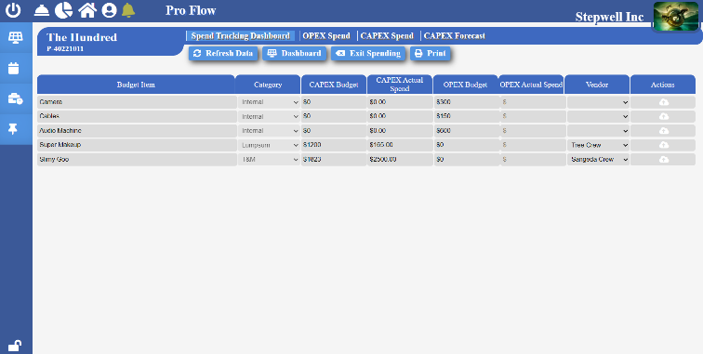

Spending Board – Dashboard

* Detailed view of all project budget item
* View CAPEX budget and actual cost
* View OPEX budget and actual cost

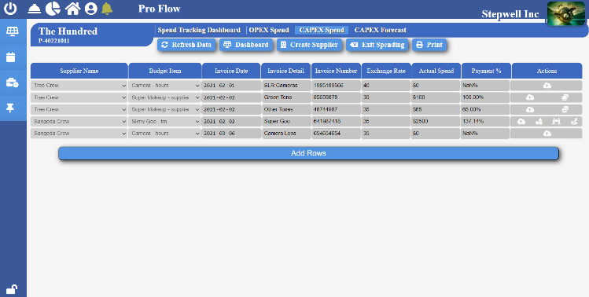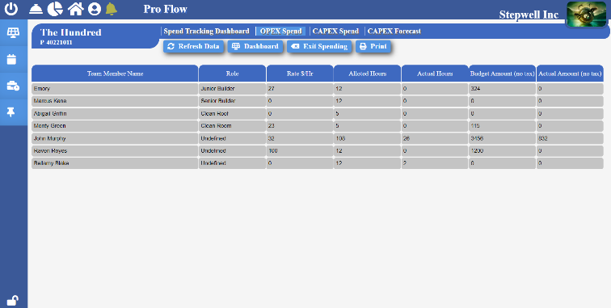

|  |  |  |  |
| --- | --- | --- | --- |
| Document Version: | _____________________________ | Document Number: | _____________________________ |
|  |  |  |  |
| Signature: | _____________________________ | Date: | _____________________________ |

Spending Board – CAPEX Spend

* Add financial information of all project suppliers
* Add invoice details
* Upload a copy of invoice for all project suppliers

Spending Board – OPEX Spend

* Detailed financial view of all project resources
* View allocated hours, actual hours, pay rate, user’s role, budget, and actual amount of company users